ICP6 Part1

Below screenshot show the created database **BIGDATA in MYSQL** and a table example is created with rows ID and name.

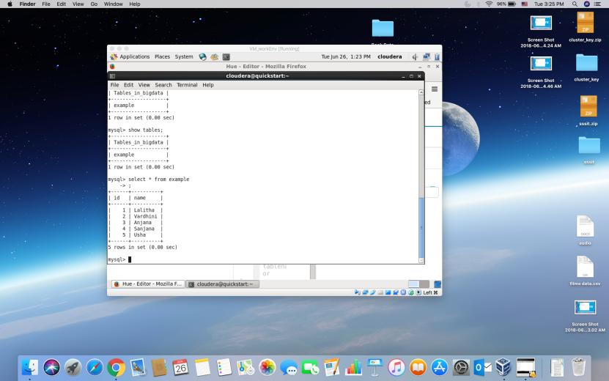

Import command is executed in sqoop and the table **EXAMPLE**  is imported to HDFS from MYSQL.

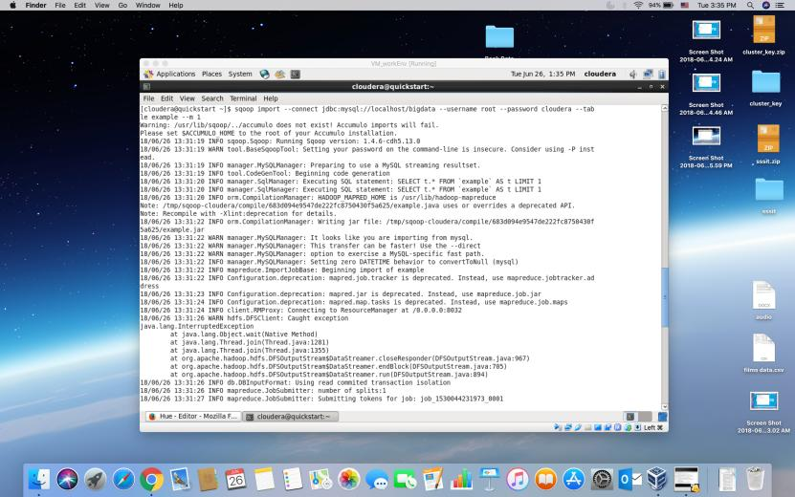

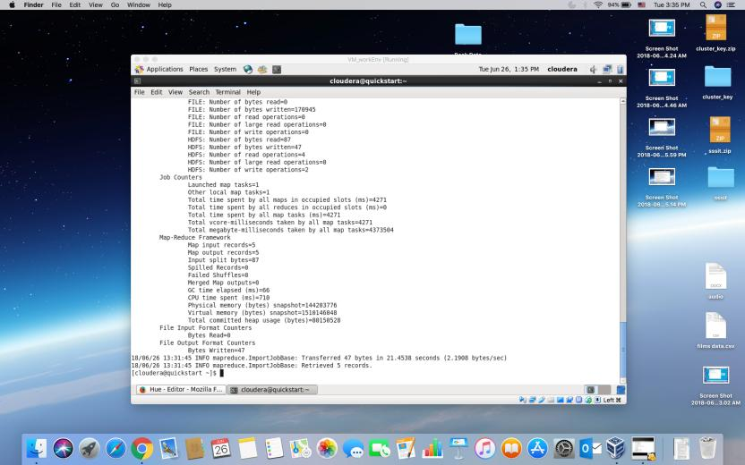

Checking the imported table in HDFS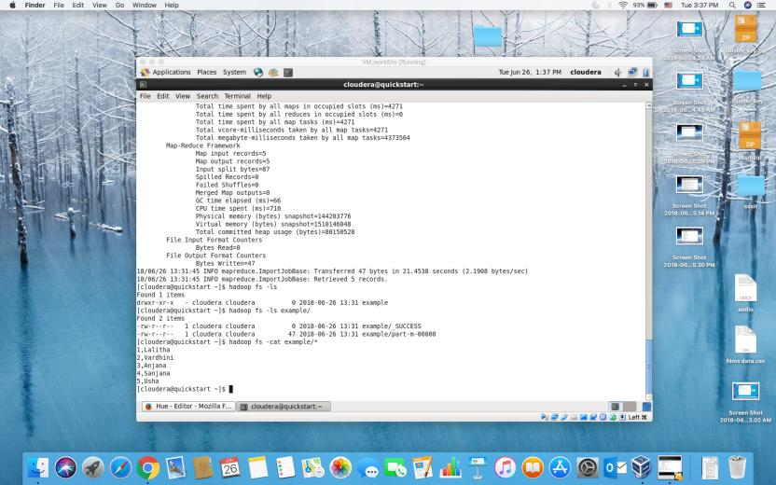

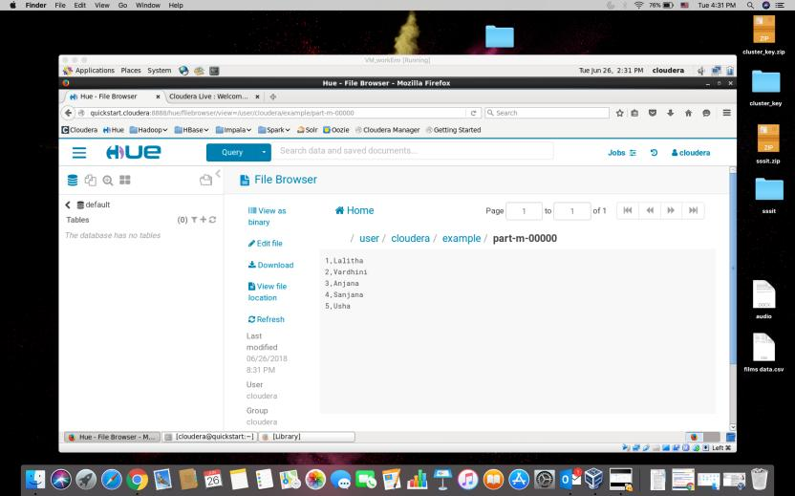

SQOOP EXPORT – exporting the same example table back to MySQL from Hadoop

Created sample table schema in MYSQL.

